4730 Colby Avenue  Everett  WA  98203  Phone: (425) 385-4023  Fax: (425) 385-4022

August 18, 2009

Becker Capital Management
1211 SW 5th Avenue, Suite 2185
Portland, OR 97204

Attached is the Investment Advisory Agreement between Becker Capital Management and the Everett School Employee Benefit Trust. Please sign and return the original to my office.

Thank you.

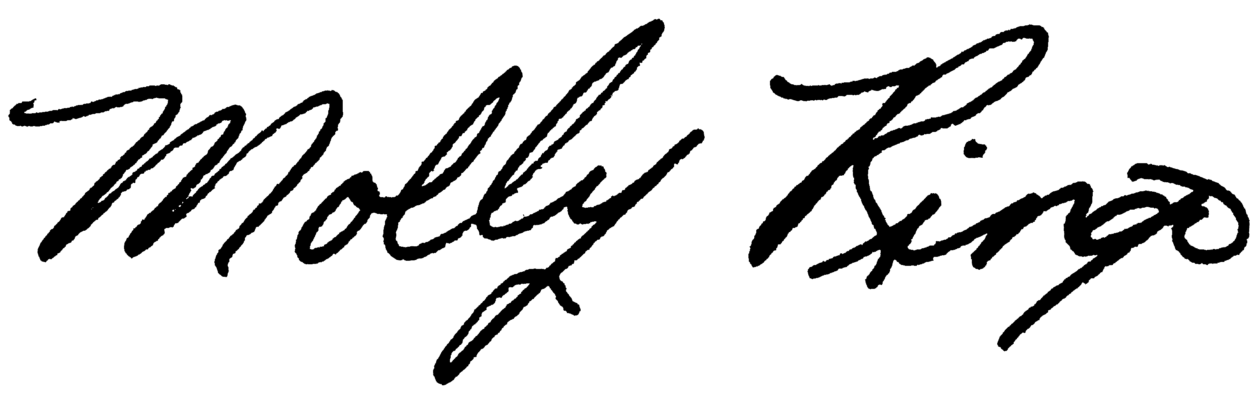

Molly Ringo, Chair
Everett School Employee Benefit Trust

attachment

